Chapter 7, Problem 72.

Find i_{o} in the op amp circuit in Fig. 7.137. Assume that v(0) = -2 V, R = 10 kΩ, and C = 10 μF.

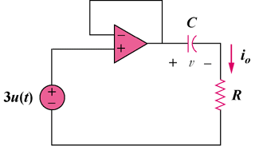

Figure 7.137
For Prob. 7.72.

